**Activity Recognition and Analysis of IoT Smart-Wearable Sensor Data and Personalised Recommender by Applying Machine Learning Algorithm**

*Abhirup Dey*

*School of Computer Science and Engineering*

*Vellore Institute of Technology*

*Vellore, Tamil Nadu, India*

*Prof. Rajkumar R*

*Department of Computer Science and Engineering*

*Vellore Institute of Technology*

*Vellore, Tamil Nadu, India*

***Abstract-- In this smart emerging world, modern day equipment, like wearable devices, not only provides functionality or advancements in lifestyles but also becoming a trending fashion choice. Most of the devices which are wearable provides basic functionalities like display time or date. But implementation of more smart features like displaying message, phone call or even medical activity recognition can lead the productivity in dense and holds a potential to create a product demanded by huge number of customers. Smart wearable devices connected to internet approaches the methodology and required application and implementation of secure IoT environment and cloud infrastructure. Compared to other internet connected devices wearable devices like smart watches are designed to be capable of monitoring activity for 24 hours a day. Mostly they are designed as durable and water resistance with addition of appropriate sensors for required functionalities and detection. In this paper we are proposing a model for identifying activity and inactivity based on sensor data with the help of a secure and smartly designed cloud infrastructure. Here we will define monitoring of heart-rate data and will discuss future enhancements by applying various machine learning methods.***

***Key Words:*** *IoT, Smart-Wearable-Devices, Cloud, Machine Learning, Web Application, Activity Recognition, Personalized Recommendation*

**1. INTRODUCTION**

21st century wearable devices like smart watches, not only offer visual display of time and date, but also gives us several other feature rich functionalities which helps to create advancement in day to day human life. Most recognised feature of a smart-watch is health monitoring. Wearable technology introduced the methodology of continuous monitoring of medical and personal data. This not only gives us productivity and efficiency, but also provides us a better way to live our life- A smart life.

Adding sensors to wearable device enhances the functionalities for collecting data about user activity. By collecting and storing the data into a database or secure storage we can provide a platform of innovation for third party vendors. There are various applications which uses the accelerometer and gyroscope data to recognise activity of individual users. Activity and inactivity recognition or users have become a current development scenario for wearable devices. But we can do a lot of enhancements and predictive approach by applying machine learning to those data set.

In this paper we will discuss about possible futuristic implementation of personalised activity recommendation based on the data collected through smart watch. Besides we will present the scenario of collecting heart rate data from test cases and predicting upcoming health issues by applying available machine learning model into it. Which does not only add valuable medical functionality, but also gives a boost to the existing scenario and an upgraded technical application.

**2. RELATED WORK**

**2.1 Smart Watch**

In the era of 90’s, watches had been designed to be connected to modern computers by integrating light sensors in it. After the invention of modern wireless technologies connectivity for smart devices has been redesigned [1].

Smart watches are wearable in hands and is placed in a particular place on body to get stable data. Consisting with screen a smart-watch is designed to be capable of displaying communication services like SMS, Facebook Feed, WhatsApp or even incoming calls. Some watches are enabled to control music and attached with camera module to capture details in stealth.

Smart watches are classified into two separate genres based on the implementation and design -

***The first type*** is known as ‘Autarkical Watch’. The type which comes with a built-in computational power and dedicated wireless connection for synchronization over the internet. Thus, the processing unit can directly process the data within the watch itself. Which undoubtedly demands more power for running [2].

***The Second type***consists of a dedicated terminal for event listening and transmitting the records to a hub like a smart-phone device. The heavy work of processing data and transmit back the events to the smart watch. In this way the smart-watch is able to save battery and no extra requirement for computational power [2].

**2.2 Activity Recognition**

Research into the field of activity recognition based on the fact of presence of various sensors in a smart-phone, is being conducted for past few years [2]. But it’s been depicted that a smart-phone is not a good choice for tracking daily activity of a person, as they keep their phone inside pockets at idle state. Which places the sensors for tracking near the thigh area and definitely not a suitable place to track activity data from a human body. Mostly people keep their phones aside after usage. In other way, the major functionality of sensor trackers can be void by the inference of other important usage purpose of a mobile phone.

Compared to a smart-phone it’s more suitable to use a smart-wearable device for tracking activity, as it is kept in a particular place of our body and track data for hours without any interruption. Smart-watch is most ideal because it is usually placed in our wrist and an individual mostly use his hand to commit most of the daily works like eating, drinking, writing or even exercise. It’s been studied that a smart-watch is capable of identifying drinking activity by an accuracy of 93.3% compared to a smart-phone with a recorded accuracy of 77.3%[3].

**2.3 Activity Unit**

The activity recognition unit identifies the activity mainly based on two sensor units which are accelerometer and gyroscope. Now the accelerometer captures the motion and positioning based on the Cartesian coordinate measurement system. It measures the three axis sensor values as x, y and z which are perpendicular to each other. The sensor values will give a similar output as gravitation force ‘g’ (9.81 m/s2). Which is calculated by the equation –

gl = ∑ (x2 + y2 + z2)0,5

Gravitational force (g) influence every object present on earth. Though the gravitational force is not constant everywhere on earth, keeping that in mind a new algorithm has been developed which defines the mean acceleration of the sensor in the 3D space in each second. This feature was deliberately given a name as “Activity Unit (AU)” and is defined by the international unit for measurement by m/s3. Regardless of the unconditional influence of gravitational force on each and every material, the AU is designed to take note only on the change of acceleration occurrence [4].

A physical jerk is accompanied to the system for the occurrence of rate of changes [2], which can represent the derivative of acceleration w.r.t time. Despite of the consideration of the acceleration being zero, low or high it detects the changes regarded. Contrasting with the jerk, the Activity Unit declare the current level of acceleration which is being occurred. As an example, the jerk will give similar result as zero when the sensor is motionless and even when the device is being transferred in a constant acceleration value. In other case the AU value is zero when it is motionless but output different value when the outcome is the case of the device being accelerated in unchanged condition. We can define the activity unit value by the following equation-

$$AU=\frac{1}{N}\sum_{n=1}^{N}{{\left({(x_{n}-x_{mean})}^{2}+{(y_{n}-y_{mean})}^{2}+{(z_{n}-z_{mean})}^{2}\right)}^{\frac{1}{2}}}$$

Here the recorded variables are –

* x, y, z are the sensor values in m/s2
* xn, yn, zn are the values received by the sensor in each readout cycle n.
* xmean, ymean, zmean are the mean of the sensor values for each axis.

During the sensors are motionless the gravity is affecting the output of those sensors. After a certain amount of time the algorithm will be unable to detect any force because of the moving average. While the sensors are rotating, they will detect different readings of ‘g’ for each axis. According to previous research implementations, assuming the sensor reading as 32 Hz and sensor rotation by 90 degree, it is required that the force of acceleration on one axis, which had no gravity influence, will be able the acquire the gravity force of one tau, which is about 63.2%, within 2 seconds. This small amount period will provide 64 data triples converted as a usable window frame for activity recognition [5]. The requirement for time leads to an average of 0.95 as a value for ‘a’ using the following equation, where the provided average is analogous to the values of ymean and zmean.

Here the recorded variables are –

* X(n)= current sensor value
* a= absolute term
* xmean(n)= calculated average
* n=readout cycle
* xmean(n-1) = calculated average for (n-1)

The calculated estimation is being measured up by the consideration of using mean acceleration values for each axis. To determine an estimation for the user activity the summed-up values of AU can depict desired output. The summation of the activity unit values can roughly determine how active the user was throughout the day. The prior can also be useful for the determination of noise for the sensor values [2].

**3. SYSTEM ARCHITECTURE AND CLOUD BUILD MODEL**

Due to low computational unit and limited power supply input from a battery around 200mAh the device itself is unable to handle the load of analysis and modelling, which are the intended features of a smart wearable. By implementing the proper utilisation of modern IoT infrastructure we will be able to connect the device to live server and by uploading the data to the server we can analyse and classify user activity. Based on the classification, the system will generate recommendation based on the application of several machine learning model. We will discuss the various models and figure out which model will be the best according to the accuracy.

The cloud architecture is established based on a particular model architecture combining several components. Which is resulting creating a hybrid model for IoT and machine learning by connecting them through a web-based platform. By adding more functionalities, we can expand due to scalability.

***3.1 Components -***

The whole architecture can be divided into two parts based on the model implementation. The first is the IoT model which is the user interaction model and the other is the machine learning part, which is the server-side model.

***(a) Device (IoT):***The device which will be attached to the user as a wearable device will be consisting of a hub of sensors collecting data from the user on a time interval set as the server requirements. Due to lack of space or computational power the user data will transfer the data temporarily to smart-phone using Bluetooth. The smart-phone will be able to send the data live to the cloud whenever it is in the range of proper internet or Wi-Fi connection.

***(b) Web Acquisition (API):*** The data which is being transferred to the smart-phone via smart wearable device, can be uploaded to the server via web APIs. Web API services are fast models for accessing and transferring data in a JSON format.

***(c) Storage (DB):*** Uploaded data through API will be stored in a Database. The database can be of two types- SQL or NoSQL. For our system simple MySQL database is implemented to reduce the cost for storage, as NoSQL architectural infrastructure demands more cost for implementation.

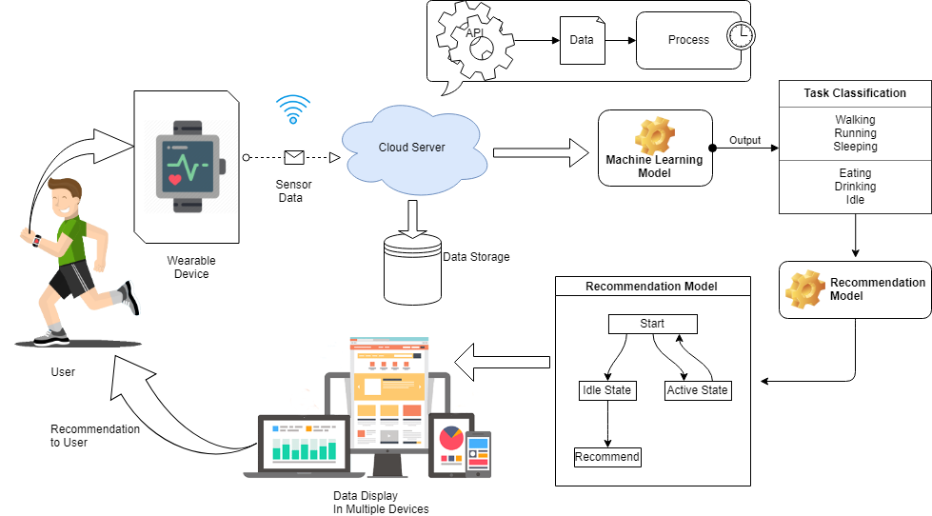

***Fig 1: System Architecture***

***3.2 Machine Learning Model Acquisition***-

The activity recognition task and the process model for recommendation will be handled by the backend infrastructure implemented on **Cloud**. So, the cloud is the major component for our system architecture. The process related to machine learning requires heavy computational power, which is pretty impossible to implement in a small device like smart-watch and can lead to unbearable expense in development. As well as a result, it will increase the product cost in such a way that customers can lose interest on buying such a product. It is evident that a user always intends to buy an upgraded version. So, if an individual is investing a huge amount of money in a particular product then the person will regret the investment when the next updated product comes to the market.

Keeping that in mind this architecture is most acceptable one, by uploading the data to cloud. Which not only reduce the cost but also opens up a huge possibility to play with the data for business values. Cloud can provide scalability and security to the data which is difficult to implement in a smart watch.

Activity classification task involves mapping time series data into a single activity collected from both smart-watch and smart-phone. Based on the activities two models are intended to be utilized, models are partitioned into two separate units. The prior one is the personal model where the other one is the impersonal model. It has been found in the previous research that the personal model hugely outperforms the impersonal model [6]. The results were generated based on the collected data from 17 subjects and each test sets were included with 10-cross fold validation. So overall 17 × 10 = 170 models were induced.

**4. OVERALL EXPERIMENT OVERVIEW**

We are about to discuss the overall process model for data collection and extraction for the full model. The initial process to the end computing the task can be divided into several parts. Based on the activity and analysis –

***4.1 Data Collection –*** Collecting the data from the user is mainly involving the hardware requirements for the system. The smart-watch and smart-phone consisting of multiple sensor hub like accelerometer, gyroscope and gravity sensor also. We were able to collect sample data from the test subject by using third-party applications. From device IoT front we have developed a device which is consisting of an accelerometer, gyroscope sensor and also a heart-rate sensor. The heart rate sensor was included as a future enhancement possibility byy implementing functionalities based on medical aspects. The Arduino sensors are able to capture the data based on the user activity, which can be collected to the database using API services. The services are platform independent and does not rely on any particular programming language. Provides faster, reliable and secure data transfer among the end-points.

The useful accessories for tracking and recording for the data collection using Arduino is available on the market in separate price range and functionalities. By certain research we have found out that two popular model exists for recording Accelerometer and Gyroscope data using Arduino – (1) MPU6050, (2) MPU9250. Now by comparison it’s been depicted that the MPU9250 provides more accurate data than MPU6050, from a user.

The data was collected from several users by attaching the module to user body. The accelerometer and gyroscope data are captured on the basis of the axis- x, y & z. The data was able to send through COM port and also by utilizing the functionalities of PyQtgraph and PyQt5, we were able to visualise the data as a live aspect. In *Fig -3* we have displayed a sample of such data plotting using python matplot library module.

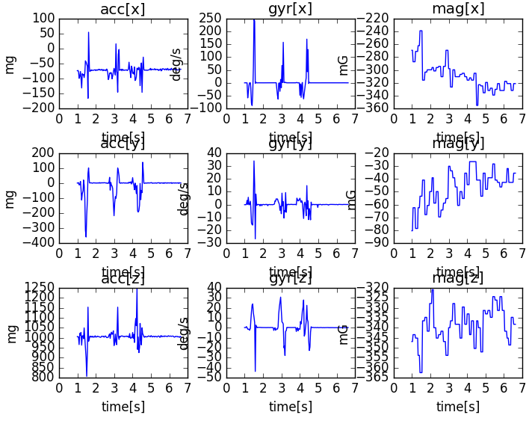

***Fig 3 – Matplotlib plotting of***

***Accelerometer and Gyroscope data***

***4.2 Dataset***­-Due to lack of user test subjects and available environment for recording huge dataset, here we have used existing datasets from open source repositories like ‘Kaggle’, ‘UCI’ for training and testing the machine-learning models. The first dataset which we used was taken from the UCI machine learning repository. The data was recorded from 30 test subjects by average age between from age 19 to age 48 years. During the data collection the users performed six different tasks like- 1. Walking, 2. Laying, 3. Sitting, 4. Standing, 5. Walking Upstairs, 6. Walking Downstairs. This data was labelled manually. The data was recorded based on the linear acceleration and angular velocity of accelerometer and gyroscope data in x, y and z axis, captured using Samsung Galaxy S II [14].

***4.3 Data Modification -***

The dataset was split into two separate parts based on subjects where 70% is the train dataset that is the 21 subjects and another is the 30% of test dataset consisting of 9 user record [9] [10]. Other data modifications are discussed within the test results accordingly.

***4.4 Heart Rate sensor Data –***

The heart rate sensor is capable of detecting pulse sensor from a user. Which is a must integrated feature available for most smart watches, as wearable devices are mostly used as a health monitoring system. We can collect and store this pulse data to generate more accurate and adequate activity recognition system. As example- when the pulse rate is high, it most likely the user is running or exercising. Similarly, when the user pulse rate is low or stable, probably he/ she is sleeping or resting. So, this data is also important for recognition system. Currently we are concentrating on the data collected from acceleration gyroscope. The heart rate data implementation into the Machine learning is kept as a future enhancement to the system [11].

**5. EXPERIMENTAL RESULTS**

Based on the datasets and model acquisitions, we have computed the results and will discuss the outcomes we preferably choose to implement on the cloud.

The training dataset loads the data as total acceleration on the basis of x, y and z axis returns a NumPy array and prints the shape of that array. The function can be demonstrated by loading all the total acceleration files. The training data comprises with 7352 rows with each window concluding 128 observations. After loading each file as a NumPy array we can easily stitch all three files together. It can be ensured that each and every file is stacked in a way the features partitioned in another dimension, using dstack() NumPy Function.

Running the sample outputs, the shape returns NumPy array by displaying the sampling and time steps for three consecutive features – x, y and z for the dataset. It’s been depicted that the size of windows in test and train datasets matches with the size of output of y in every train and test case replicates the sample number.

A balanced dataset is always easier to model. So to confirm if the dataset is actually reaching the expectations or not, we are using a function *class_breakdown()* to implement this characteristics. The function first wraps the given NumPy array, then groups out the class value, and evaluate the size of every group based on number of rows. The result is being summarised in the following tables-

TABLE- TRAIN DATASET

|  |  |  |
| --- | --- | --- |
| **Class** | **Total** | **Percentage(%)** |
| Class-1  Class-2  Class-3  Class-4  Class-5  Class-6 | 1226  1073  986  1286  1374  1407 | 16.676  14.595  13.414  17.491  18.89  19.137 |

TABLE- TEST DATASET

|  |  |  |
| --- | --- | --- |
| **Class** | **Total** | **Percentage(%)** |
| Class-1  Class-2  Class-3  Class-4  Class-5  Class-6 | 496  471  420  491  532  537 | 16.831  15.982  14.252  16.661  18.052  18.222 |

TABLE- BOTH DATASET

|  |  |  |
| --- | --- | --- |
| **Class** | **Total** | **Percentage(%)** |
| Class-1  Class-2  Class-3  Class-4  Class-5  Class-6 | 1722  1544  1406  1777  1906  1944 | 16.72  14.992  13.652  17.254  18.507  18.876 |

Running the summarization for the dataset is reflecting how classes are distributed between 13% – 19%, assuming the distribution classes are balanced.

The time series data collected from the users may have repetition of data for each variable. So, we had to remove the overlapping possibilities. By using *unique()* function we were able to retrieve unique objects from the dataset. Once we have data for one subject, we will be able to plot it. By plotting 9 series of the subject activity level, we will have similar number of time steps which will be essential for creating a sub-plot for each variable and align them in a vertical manner for comparison of movement or activity.

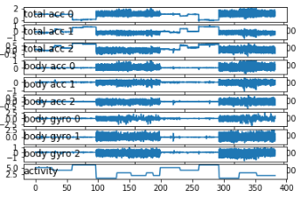

Fig – Plot for Single Subject Variables

In the plot we can see high frequency in the region of walking activities and low frequency in the range of activities like sitting, standing or laying.

Based on the activity data we would be interested to analyse it in a way to determine the activity performed by each subject. This can be achieved by plotting histogram model for each activity relied on the three axis values of x, and z. The plotted graphs are demonstrated horizontally to distinguish between them, accordingly.

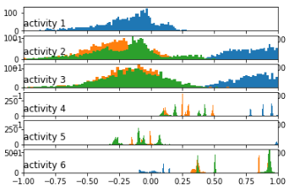

*Fig- Histogram of activity based on Acceleration*

We have got the output by running the machine learning model for the acceleration data based on the data for each axis- x, y and z depicted in the picture blue, orange and green respectively.

According to the result it is clearly visible that the plotting is distributed in larger scale for first three activities which are moving activities, and the graph is distributed in small scale with multiple picks for idle state like sitting, standing or sleeping.

Applying the similar code for plotting graph using the gyroscope data for a particular subject we get the following result –

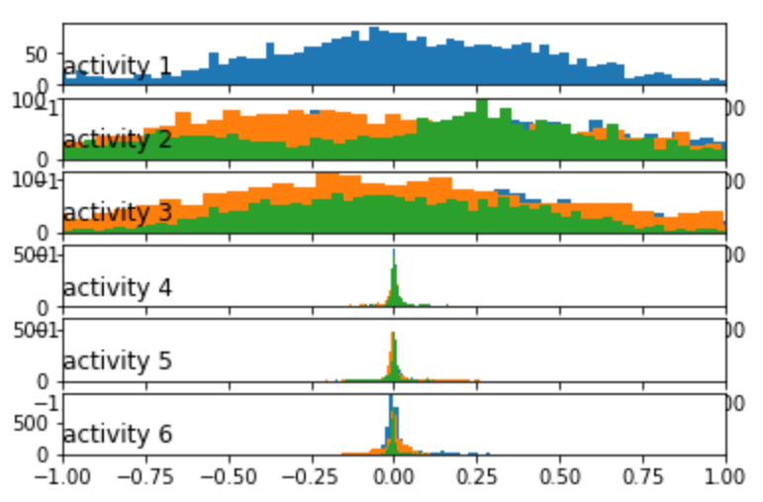

*Fig- Histogram of activity based on Gyroscope*

We can see Gaussian alike fat-tailed distribution of the data for active state which is different from the plotting for the acceleration data. It is also clearly visible that the graph is unflatter while the activity is in relaxed state.

These data is generated from one subject. By applying similar model for other subject data, we also generated graphs with identical pattern. From that the activity recognition is evident.

The data was collected on the basis of various activity data taken from 30 separate individuals. Though we will concentrate on a particular activity for this instance. Eventually, we can repeat the process for all kind of activity and analyse in the same manner. So here we are concentrating on the walking data only. Walking is a very common activity for human also a very good exercise.

Based on the Walking activity over time period for each individual the feature taken as the angle between X axis and mean gravity which is apparently constant, we can plot graphs for all individual. By iterating the list of objects inside parameters we can specify the size of graph in *rcParams.* In the plotting the first parameter is the X-axis data which is the time data and the second parameter is the Y-axis data which is angle between X-axis and gravity.

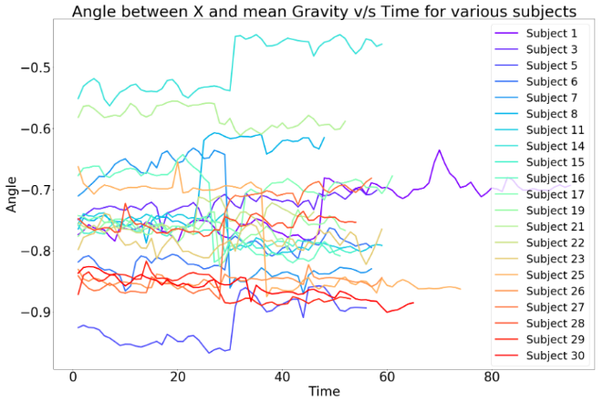

**Classify Activity-**

The classification of activity based on various algorithm differs based on accuracy constrains. We will discuss four models applied for this data set and compare the results to pursue the most suitable choice.

In this experiment we have used four different algorithms – Support Vector Classifier (SVC), Logistic Regression (LR), K Nearest Neighbour (KNN) and Random Forest (RF). We have converted the accuracy score to percentage by multiplying the output with 100 for each.

|  |  |
| --- | --- |
| **Algorithm** | **Accuracy (%)** |
| SVC  LR  KNN  RF | 94.02782490668477  96.19952494061758  90.02375296912113  89.68442483881914 |

So, we can see that the algorithm of Logistic regression reaches the most accuracy among the other models which is around 96%. The comparison data is visualized in the above table.

**6. RECOMMENDER SYSTEM**

Based on the activity monitored by the wearable device, we can track what a particular person is doing for a period of time and what is his interest. We can recommend something based on that activity to that person when the person is apparently idle. For example, you can recommend a person for watching movies, or listening to songs or to do exercise when the person is idle for a long time.

This kind of recommendation can be achieved by using data collected from various users and we can analyse the trending activities, which others are doing. Mostly people from same region would like to watch similar kind of movies available for release. So, for recommendation to a single person, both that person’s data and the other user’s activity data is important. Forming neural network to model this kind of recommendation system is a highly challenging scenario. We will discuss the methodology, classification and process for implementing such a recommender system.

Basically, there are to different kind of filtering techniques for recommender system-

***Content-based Filtering-*** In this filtering process we can generate a list of properties for certain activities. If an individual’s activity matches with the certain category, then we can recommend that person an activity. So, let’s take an example-

|  |  |  |  |
| --- | --- | --- | --- |
|  | Waking | Sitting | Sleeping |
| Hand oriented | No | No | No |
| Non-hand Oriented | Yes | Yes | No |
| Both hand and non-hand oriented | Yes | Yes | No |

The above table is classifying three basic activity of a person like walking, sitting and sleeping based on the engagement of hand orientation. So, if a person if more active in hand-oriented work, then we can suggest him/her to do more non-hand-oriented work to maintain a balance between all parts of body, and may suggest to do a little exercise to stay fit. We can rank activities for a person’s interest based on the record of his past activity.

***Collaborative Filtering-*** This kind of filtering is based on the other user activity data. Surveying certain activities liked by an individual, we can predict similar interest for another person. Different places will generate this data in different ways. We can also classify the data using the time and date perspective. Also, there is another possibility for filtering age-based activity. Because in certain ages people grows interest on certain things. Like a teenager is more likely to be watching Netflix than a news channel.

|  |  |  |  |
| --- | --- | --- | --- |
|  | Waking | Sitting | Sleeping |
| User 1 | Yes | No | No |
| User 2 | No | Yes | No |
| User 3 | Yes | No | Yes |
| User 4 | Yes | Yes | No |

3 Votes 2 Votes 1 Vote

Let’s take another example, here we can see that the activities are classified based on user. User 1, User 3 and User 4 has recorded activity of walking. But User 2 is likely to be sitting most of the time. Based on that perspective our system might recommend ‘user 2’ to go for a walk.

***Restrictive Boltzmann Machine-***

The Restrictive Boltzmann Machine is a learning model notably applicable for such a scenario we are implementing here. The RBM is a simple neural network consisting of two layers- one is the visible or input layer and the other is the hidden layer.

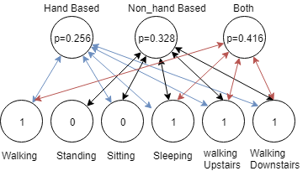

Here is a simple example calculated probability based on ‘hand’ or ‘non-hand-oriented’ activity applied on six recorded activity data of an individual. As a result, we can see here that the probability for both usage of hand or non-hand orientation is the highest with a value of p=0.416 for this individual. So, it’s obvious to suggest that person to do something which involves both Hand and Non-hand-oriented postures. Now, it is also required to keep on note that, if a particular person is working too hard for a long time, then the recommendation system should suggest to take rest or to relax to that user.

There are lots of algorithms tested and researched with certain equations and functions. We would like to find out better solution for implementing such functionality with lesser work load and computational power, so that it is easy to implement in smart phone like devices. So, the result will be faster and more local.

**7. FUTURE ENHANCEMENTS**

Smart wearable device undoubtedly one of the most trending technological advancement in the modern world. By the invention of foldable screen technology, which is more applicable devices which are being wear on an uneven surface like wrists. It is also being targeted to be more durable, cheap and feature rich.

The ideology for implementing such a recommender system based on the collected data from users, is a unique and futuristic concept. We can promote such system for product advertisement and business prospects. By applying this recommendation system to the world-wide market place and online business it can be made more flexible and easier for user interaction.

This proposed work is in its earlier stage. We will be keep working for adding more functionalities and better logical implementation so that the whole world can utilise this as a acceptable option, and not only for personal usage but also for business reasons.

By adding more advanced sensor and faster cloud technologies the system would be more capable of delivering most awaited features to customers.

**8. CONCLUSION**

In this paper we have introduced a smart wearable device implementation using IoT cloud platform and then applying machine learning algorithm we are recognising activity for certain individuals. Adding recommender system to that data output we are able to recommend activities to users.

Due low-cost implementation we were unable to collect raw data which is suitable for certain machine learning model. The more the data the better output for this activity recognition system. Despite we have found out certain flaws in the system which must be improved in later research and implementation.

1. The acceleration and gyroscope data must be accurate and easy to record using API.
2. Sometimes the data is not being loaded properly into the system database.
3. The intelligent model in cloud is unable to distinguish activity performed in certain aspects, like sitting inside room vs sitting inside a car.
4. The moving data is inaccurate to distinguish between walking and jogging.
5. Location based classification is not possible because no GPRS system is implemented.

We would like to disqualify this kind of issues by upgrading requirements for the system and by using advanced devices for the system.

This proposed model has huge possibilities for future enhancements and including more features or functionalities can be possible by adding more sensors into it. We are aware about the fact that big business companies are investing a chunk amount of money for this kind of recommendation system to grow their business and reach out more user. Even 10% revenue in the business aspects can bring huge profit in overall.

**REFRENCES**

[1] Lloyd C.: Time Comes for the Superwatch, The Times, Newspaper, 3 Thomas More Square, London, E98 1XY, 13. Jan. 199

[2] *Sensor requirements for activity recognition on smart watches*, Conference: Proceedings of the 6th International Conference on PErvasive Technologies Related to Assistive Environments, May 2013

[3] *Smartwatch-based Activity Recognition: A Machine Learning Approach,* Gary M. Weiss, Jessica L. Timko, Catherine M. Gallagher, Kenichi Yoneda, and Andrew J. Schreiber

[4] SI - International Bureau of Weights and Measures, The International System of Units (SI), Brochure (8th ed.), 2006, ISBN 92-822-2213-6

[5] Bieber G., Voskamp J., Urban B., Activity Recognition for Everyday Life on Mobile Phones, Lecture Notes in Computer Science, Volume 5615/2009, pp.289-296, Springer Berlin / Heidelberg, 2009, ISSN 0302-9743

[6] I. H. Witten, and E. Frank - Data Mining: *Practical Machine Learning Tools and Techniques,* 2nd ed., Morgan Kaufmann, 2005.

[7] I. H. Witten, and E. Frank - Data Mining: *Practical Machine Learning Tools and Techniques,* 2nd ed., Morgan Kaufmann, 2005.,

[8] Anguita, Davide, Ghio, Alessandro Oneto, Luca Parra Perez, Xavier Reyes Ortiz, Jorge Luis - *A public domain dataset for human activity recognition using smartphones, ISBN978-2-87419-081-0, 2013*

[9] *Human Activity Recognition on Smartphones Using a Multiclass Hardware-Friendly Support Vector Machine* –by Davide AnguitaAlessandro GhioLuca OnetoXavier ParraJorge L. Reyes-Ortiz, IWAAL 2012: Ambient Assisted Living and Home Care pp 216-223

[10] Dataset- Human Activity Recognition with Smartphones Recordings of 30 study participants performing activities of daily living. [*https://www.kaggle.com/uciml/human-activity-recognition-with-smartphones*](https://www.kaggle.com/uciml/human-activity-recognition-with-smartphones)

[11] Wearable Multisensor Heart Rate Monitor, Grajales, L., & Nicolaescu, I. V. (n.d.). Wearable Multisensor Heart Rate Monitor. International Workshop on Wearable and Implantable Body Sensor Networks (BSN’06). doi:10.1109/bsn.2006.58

[12] J. Yang, “Toward physical activity diary: Motion recognition using simple acceleration features with mobile phones,” In First Int. Workshop on Interactive Multimedia for Consumer Electronics at ACM Multimedia, pp. 1-10, 2009